問題9

元金，利子を入力して，元金の2倍になるまでの預金額と利子を計算するプロシジャーを作成しなさい．

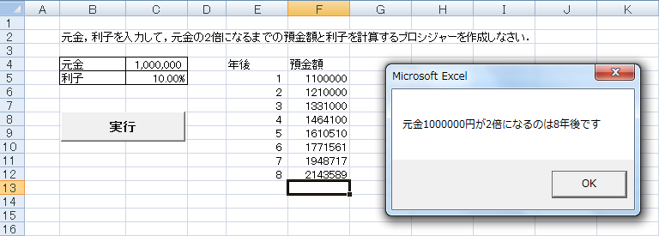

Sub yokin()

Dim gankin, gankin2 As Long

Dim rishi As Single

Dim year As Integer

gankin = [ 1 ]

rishi = [ 2 ]

year = 0

gankin2 = gankin

Range("[ 3 ]").Select

Do While [ 4 ]

[ 5 ]

gankin2 = gankin \* (1 + rishi) ^ year

ActiveCell.Offset(0, -1).Value = [ 6 ]

ActiveCell.Offset(0, 0).Value = [ 7 ]

ActiveCell.Offset(1, 0).Select

Loop

MsgBox "元金" & gankin & "円が2倍になるのは" & year & "年後です"

End Sub