問題8

指定した列数と行数の九九の表を作成しなさい．

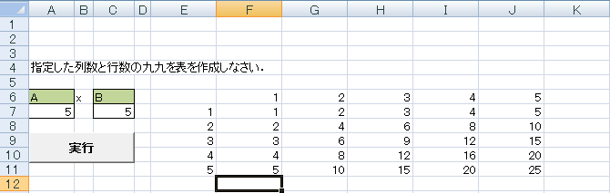

Sub kuku()

Dim A, B As Integer

A = [ 1 ]

B = [ 2 ]

Range("E7").Select

For i = [ 3 ]

ActiveCell.Offset(0, 0).Value = i

[ 4 ]

Next i

Range("F6").Select

For ｊ = [ 5 ]

ActiveCell.Offset(0, 0).Value = ｊ

[ 6 ]

Next ｊ

Range("F7").Select

For i = [ 7 ]

For j = [ 8 ]

ActiveCell.Offset(0, j - 1).Value = [ 9 ]

Next j

ActiveCell.Offset(1, 0).Select

Next i

End Sub