問題7-1

数学，英語，理科，社会の4教科の合計をF列に計算しなさい．また，合計が320点以上であれば「A」，280点以上320点未満であれば「B」，240点以上280点未満であれば「C」，240点未満であれば「D」とG列に表示させなさい．この処理を，判定をIF文とSELECT文でおこなうプロシジャーを作成しなさい．

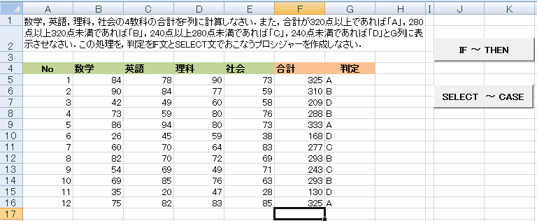

Sub goukei1()

Dim math, eng, sci, soci, sum As Integer

[ 1 ]

Do While [ 2 ]

math = ActiveCell.Offset(0, 0).Value

eng = [ 3 ]

sci = [ 4 ]

soci = [ 5 ]

sum = [ 6 ]

ActiveCell.Offset(0, 4).Value = [ 7 ]

If [ 8 ] Then

[ 9 ] = "A"

ElseIf [ 10 ] Then

[ 11 ] = "B"

ElseIf [ 12 ] Then

[ 13 ] = "C"

Else

[ 14 ] = "D"

End If

ActiveCell.Offset(1, 0).Select

Loop

End Sub

Sub goukei2()

Dim math, eng, sci, soci As Integer

[ 1 ]

Do While [ 2 ]

math = ActiveCell.Offset(0, 0).Value

eng = [ 3 ]

sci = [ 4 ]

soci = [5 ]

ActiveCell.Offset(0, 4).Value = [ 6 ]

Select Case [ 7 ]

Case [ 8 ]

[ 9 ] = "A"

Case [ 10 ]

[ 11 ] = "B"

Case [ 12 ]

[ 13 ] = "C"

Case Else

[ 14 ] = "D"

End Select

ActiveCell.Offset(1, 0).Select

Loop

End Sub

問題7-2

数学，英語，理科，社会の4教科の合計をF列に計算しなさい．また，合計が320点以上であれば「A」，280点以上320点未満であれば「B」，240点以上280点未満であれば「C」，240点未満であれば「D」とG列に表示させなさい．この処理を，判定をIF文でおこなうプロシジャーを作成しなさい．

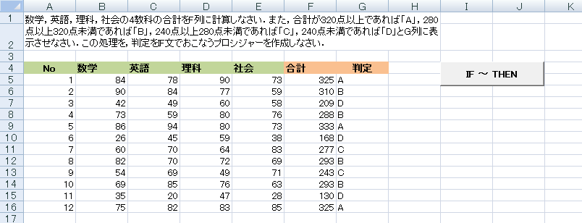

Sub goukei3()

Dim sum As Integer

[ 1 ]

Do While ActiveCell.Value <> ""

sum = 0

For i =[ 2 ]

sum = [ 3 ]

Next i

ActiveCell.Offset(0, 4).Value = [4 ]

If sum >= 320 Then

[ 4 ]

ElseIf sum >= 280 Then

[ 5 ]

ElseIf sum >= 240 Then

[ 6 ]

Else

[ 7 ]

End If

ActiveCell.Offset(1, 0).Select

Loop

End Sub