問題6

身長とBMIの値（上限と下限）と刻み幅を入力し，それらの値に対応する体重を計算するプロシジャーを“For ～ Next”と“Do While ～ Loop” を使ってそれぞれ作成しなさい．

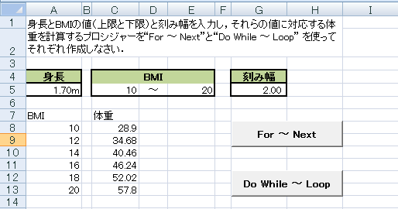

Sub hantei1()

Dim height, weight As Single

Dim bmi1, bmi2, haba As Single

height = [ 1 ]

bmi1 = [ 2 ]

bmi2 = [ 3 ]

haba = [ 4 ]

Range("a8").Select

For i = [ 5 ]

weight = i \* height ^ 2

[ 6 ] = i

[ 7 ] = weight

[ 8 ]

Next i

End Sub

Sub hantei2()

Dim height, weight As Single

Dim bmi1, bmi2, haba As Single

height = [ 1 ]

bmi1 = [ 2 ]

bmi2 = [ 3 ]

haba = [ 4 ]

Range("a8").Select

Do While [ 5 ]

weight = bmi1 \* height ^ 2

[ 6 ] = bmi1

[ 7 ] = weight

[ 8 ]

bmi1 = [ 9 ]

Loop

End Sub