問題5

元金，利子，年数を入力して，各年の預金額と利子を計算するプロシジャーを作成しなさい．

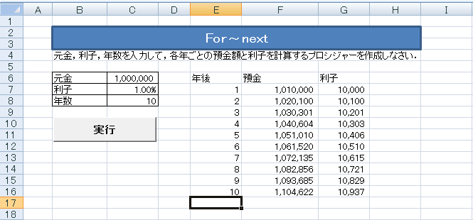

yokinのプロシジャー

による出力

Sub yokin()

Dim gankin As Long, rishigaku As Long

Dim rishi As Single

Dim year As Integer

gankin = [ 1 ]

rishi = [ 2 ]

year = [ 3 ]

Range([ 4 ]).Select

For n = [ 5 ]

rishigaku = [6 ]

[ 7 ] = gankin + rishigaku

ActiveCell.Offset(0, 0).Value = [ 8 ]

ActiveCell.Offset(0, 1).Value = [ 9 ]

ActiveCell.Offset(0, 2).Value = [ 10 ]

ActiveCell.Offset(1, 0).Select

Next n

End Sub