問題

商品名と個数を入力して，支払い金額を計算しなさい．ただし，商品にない品物や在庫量より多くの個数を入力した場合は，「エラー」と出力させなさい．

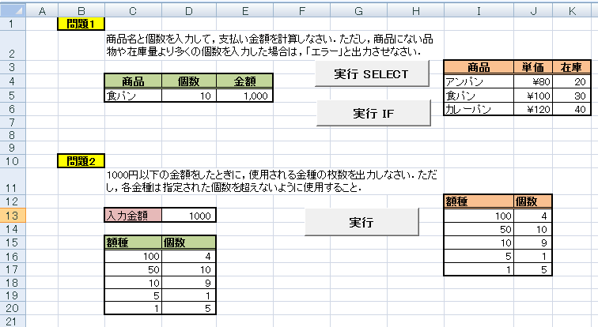

Sub kingaku1()

Dim kosu As Integer

Dim syohin As String

syohin = InputBox("商品名を入力してください")

kosu = InputBox("個数を入力してください")

Range("c5").Value = [ 1 ]

Range("d5").Value = [ 2 ]

Select Case syohin

Case "アンパン"

If [ 3 ] Then

Range("e5").Value = kosu \* Range("j4").Value

Else

Range("e5").Value = "エラー"

End If

Case "食パン"

If [ 4 ] Then

Range("e5").Value = [ 5 ]

Else

Range("e5").Value = "エラー"

End If

Case "カレーパン"

If [ 6 ] Then

Range("e5").Value = [ 7 ]

Else

Range("e5").Value = "エラー"

End If

Case Else

Range("e5").Value = [ 8 ]

End Select

End Sub

Sub kinsyu()

Dim maisu, kingaku As Integer

kingaku = [ 1 ]

maisu = Range("j13").Value

If kingaku \ 100 <= [ 2 ] Then

Range("d16").Value = [ 3 ]

kingaku = kingaku Mod 100

Else

Range("d16").Value = [ 4 ]

kingaku = kingaku - maisu \* 100

End If

maisu = [ 5 ]

If kingaku \ 50 <= [ 6 ] Then

Range("d17").Value = [ 7 ]

kingaku = [ 8 ]

Else

Range("d17").Value = [ 9 ]

kingaku = [ 10 ]

End If

maisu = [ 11 ]

If kingaku \ 10 <= [ 12 ] Then

Range("d18").Value = [ 13 ]

kingaku = [ 4 ]

Else

Range("d18").Value = [ 15 ]

kingaku = [ 16 ]

End If

maisu = [ 17 ]

If kingaku \ 5 <= [ 18 ] Then

Range("d19").Value = [ 19 ]

kingaku = [ 20 ]

Else

Range("d19").Value = [ 21 ]

kingaku = [ 22 ]

End If

Range("d20").Value = [ 23 ]

End Sub