問題11

データの合計を計算しなさい．

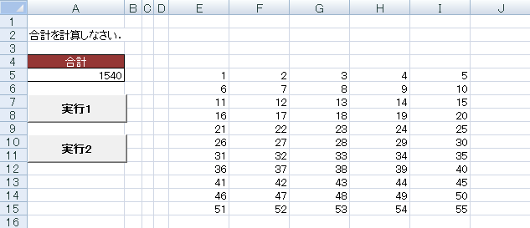

Sub gokei()

Dim i, nc, sum As Integer

Range("e5").Select

nc = 0

Do While ActiveCell.Value <> ""

[ 1 ]

[ 2 ]

Loop

ActiveCell.Offset(0, [ 2 ]).Select

sum = 0

Do While ActiveCell.Value <> ""

For i = [ 3 ]

sum = [ 4 ]

Next i

ActiveCell.Offset(1, 0).Select

Loop

Range("a5").Value = [ 5 ]

End Sub

Sub gokei2()

Dim i, sum As Integer

Range("e5").Select

sum = 0

Do While ActiveCell.Value <> ""

i = 0

Do While ActiveCell.Value <> ""

sum = [ 1 ]

[ 2 ]

ActiveCell.Offset(0, [3 ]).Select

Loop

ActiveCell.Offset(1, [ 4 ]).Select

Loop

Range("a5").Value = [ 5 ]

End Sub