練習問題3（教科書145ページ）
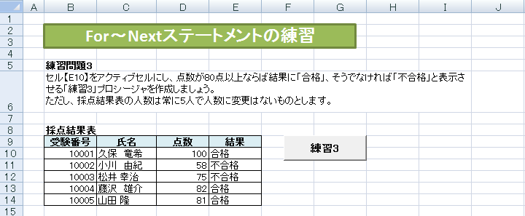

Sub 練習3()
Dim i As Integer

Range("E10").Select

For i = [ 1 ]
If ActiveCell.Offset( [ 2 ] ).Value >= 80 Then
ActiveCell.Value = [ 3 ]
Else
ActiveCell.Value = [ 4 ]
End If
ActiveCell.Offset(1, 0).Select
Next
End Sub

練習問題4（教科書145ページ）
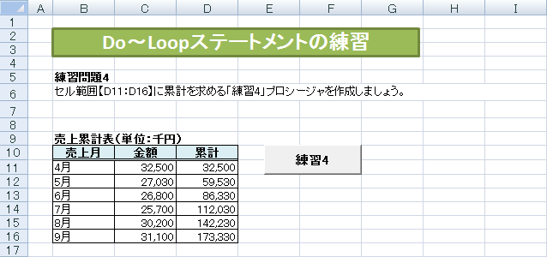

Sub 練習4()
Dim total As Single

Range( [ 1 ] ).Select
Do While ActiveCell.Value <> ""
total = total + [ 2 ]
ActiveCell.Offset(0, 1).Value = [ 3 ]l
ActiveCell.Offset(1, 0).Select
Loop
End Sub

